Experiment 3: Conservation of Mechanical Energy

Amanda Wei

505 106 664

05/10/2019

Thursday 8am

Steve Mendoza

John Field

**Discussion**

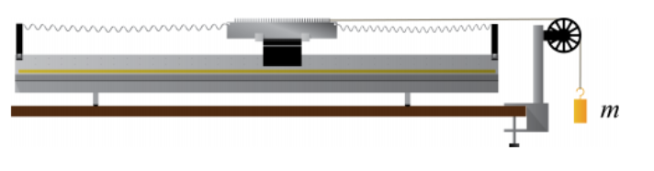**Figure 1. Spring Constant Setup** Setup for measuring the spring constant. No mass was attached in determining energies.1

At equilibrium, the middle (30th tooth of the comb) just barely covered the photogate’s light, and it was at 146.1±0.5 cm from the left edge of the air track. At each trial, the glider was pulled to the right so that the equilibrium was at 159.0±0.5 cm from the left.

Various masses were attached to determine the spring constant. We used the formula F=-kx to find k, the spring constant. For each mass *m*, a gravitational force was calculated by calculating 9.8\**m*, and then measuring how much the mass displaced the glider from equilibrium. A plot of force versus displacement was made, and a line of best fit whose slope was 6.26±0.06 N/m, which was used as the spring constant in our calculations.

After releasing the glider, time data points were recorded each time a tooth passed through the photogate. The length of the comb was measured to be 24 cm, and 60 teeth were counted on the comb so each tooth-gap pair covers a distance of 0.4±0.003 cm.

A column of distance measuring displacement from equilibrium was created by subtracting the block number from 30, (since the 30th block is at equilibrium and we are counting the number of blocks from the edge of the comb) and multiplied by 0.4 (which is the length of each block-gap pair. This gives us how much the comb has moved from equilibrium.

To calculate kinetic energy, we had to create a column of velocity values at each point first. This was done by taking the difference between the current position and the previous position and dividing by the difference between the last two time data point values ($v=\frac{x_{2}-x_{1}}{t_{2}-t_{1}}$). Since there was no data collected before the first data point, the number of velocity data (and also kinetic energy) is one less than the position data points. Then, we used $KE=\frac{1}{2}mv^{2}$ to calculate kinetic energy (where mass *m* is in kilograms, and velocity *v* in meters per second.)

Potential energy was calculated using the formula $U=\frac{1}{2}kx^{2}$, where the spring constant *k* is measured in N/m and position *x* is measured in meters.

Total energy at each point is the sum of kinetic and potential energies: $E = KE+U$.

**Plots and Tables**

Combined mass of glider and comb: $m=223.5 ± 0.5 g =0.2235 ± 0.0005 kg$.

Data used to calculate spring constant *k*:

|  |  |  |
| --- | --- | --- |
| Hanging mass (*kg*) | Force ($F=m×9.8 N$) | Displacement from Equilibrium (*m*) |
| 5.0 ± 0.05 | 0.0490 ± $(4.9×{10}^{-4}$) | 0.0080 ± ($5.0×{10}^{-5}$) |
| 10.0 ± 0.05 | 0.0980 ± $(4.9×{10}^{-4}$) | 0.0155 ± ($5.0×{10}^{-5}$) |
| 20.0 ± 0.05 | 0.1960 ± $(4.9×{10}^{-4}$) | 0.0310 ± ($5.0×{10}^{-5}$) |
| 25.0 ± 0.05 | 0.2450 ± $(4.9×{10}^{-4}$) | 0.0385 ± ($5.0×{10}^{-5}$) |
| 30.0 ± 0.05 | 0.2940 ± $(4.9×{10}^{-4}$) | 0.0470 ± ($5.0×{10}^{-5}$) |
| 35.0 ± 0.05 | 0.3430 ± $(4.9×{10}^{-4}$) | 0.0550 ± ($5.0×{10}^{-5}$) |

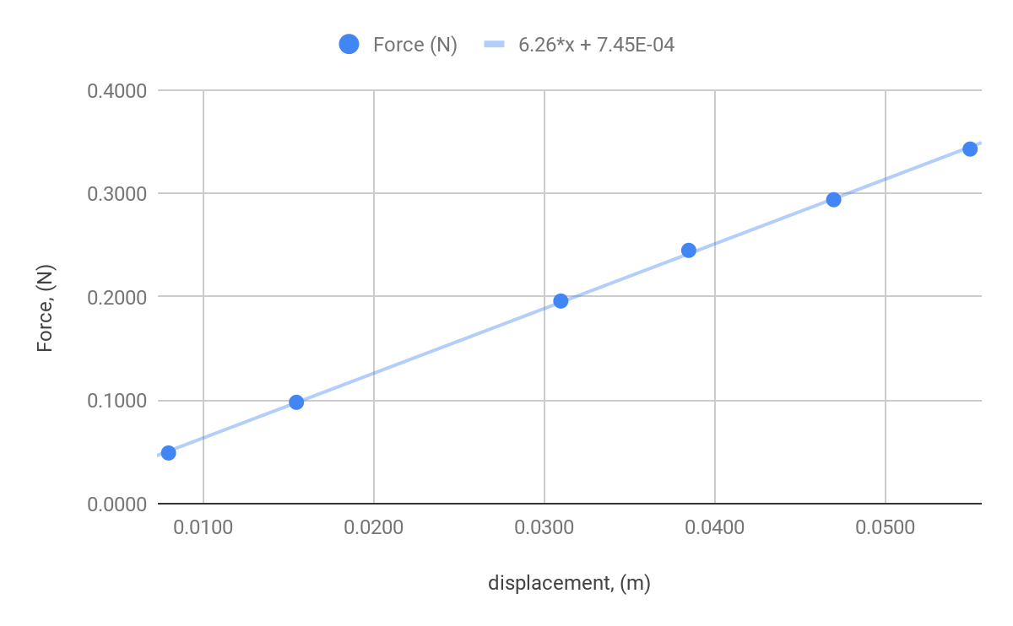

**Figure 2. Spring Constant Data** The spring constant was determined from the slope of the line of best fit of the data points that map displacement to gravitational force. After performing LINEST() on the data, $k=6.26±0.06 N/m$.

The following three graphs display data collected from each of three trials. In each graph, red squares represent potential energy, blue triangles represent kinetic energy, and yellow diamonds represent total energy. The energies are graphed as a function of distance from equilibrium. From the data points of the total energy, a line of best fit is illustrated in black. Note that potential energy reaches 0 when the glider-comb mass reaches equilibrium, while at that point kinetic energy reaches a maximum. Meanwhile, the total energy which is the sum of kinetic and potential energies remains practically constant.

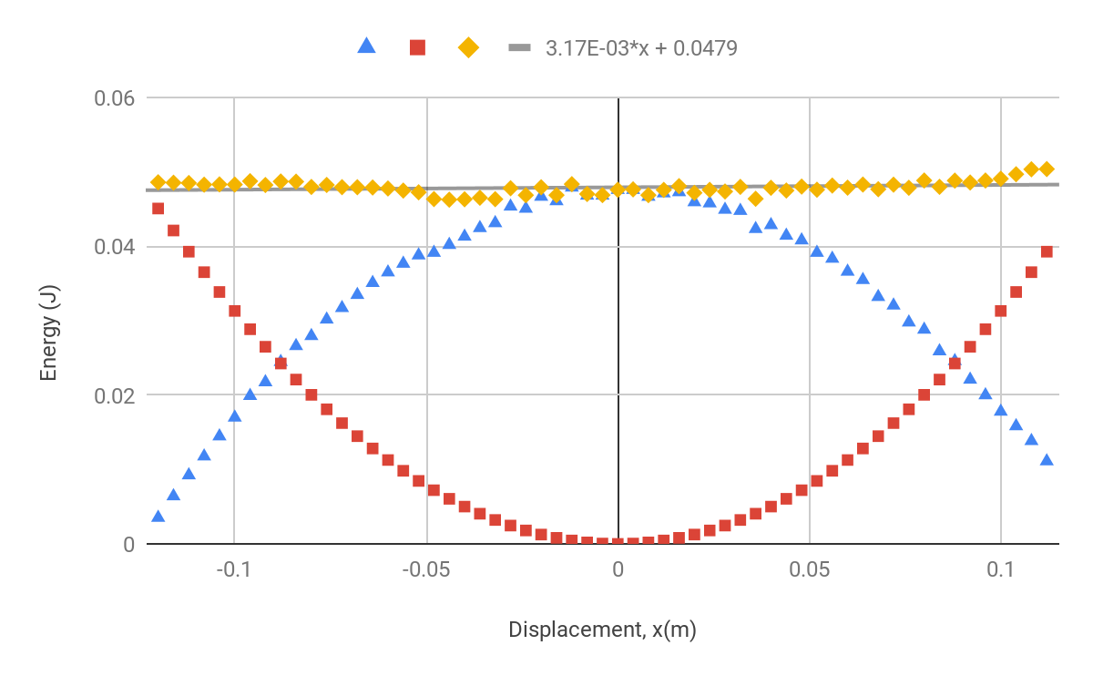

**Figure 3. Trial 1, Energy vs. Displacement** slope of line of best fit: $b=0.00317±0.0017 N/m$.

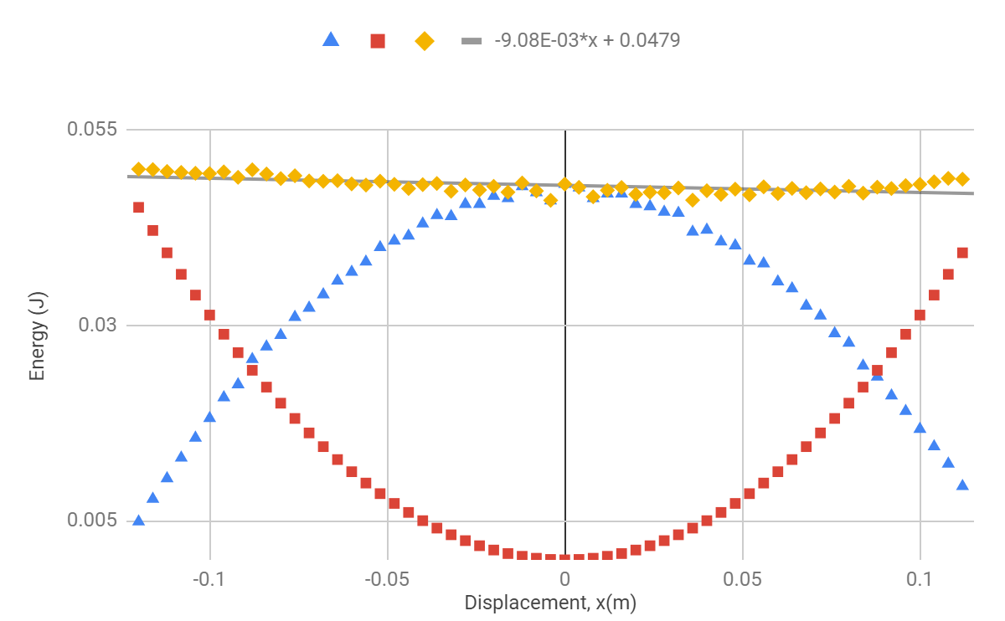

**Figure 4. Trial 2, Energy vs. Displacement** slope of line of best fit: $b=-0.00908±0.0015 N/m$.

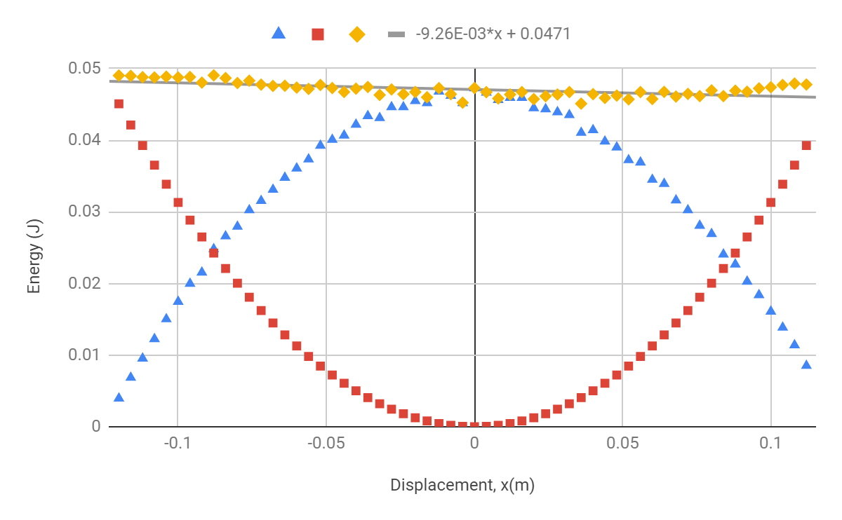

**Figure 5. Trial 3, Energy vs. Displacement** slope of line of best fit: $b=-0.00926±0.0015 J/m$.

**Coefficient of Friction:**

(Calculations are based on data from the third trial only)

Variables:

*b*: slope of the line of best fit

*μ:* coefficient of friction

$F_{N}$: normal force

Since the line of best fit represents the line of total energy, theoretically due to conservation of energy, we expect it to be constant (slope b=0). Practically, however, energy is lost to friction so the slope is non-zero and is a measurement of energy loss.

In the energy-work function, which was not included in the calculation of total energy in the graphs, there is a work function $W=F_{f}d$ which is the energy lost to friction. Since the slope of the line of best fit measures change in energy (work) per meter, the slope is really friction force. (We have the following:

$b=μ*F_{N}$

$μ=\frac{b}{F_{N}} ± (\frac{b}{F_{N}}×\sqrt{{(\frac{δb}{|b|})}^{2}+{(\frac{δF_{N}}{|F_{N}|})}^{2}})$

*b* is given by the slope of the line of best fit in Figure 5:

$b=-0.00926±0.0015 N$

$F_{N}=F_{g}=mg=2.1903$ ± $(5.0×{10}^{-4}$) *N*

Then

$μ=\frac{0.00926}{2.1903} ± (\frac{0.00926}{2.1903}×\sqrt{{(\frac{0.0015}{0.00926})}^{2}+{(\frac{0.0005}{2.1903})}^{2}})$

*=* 0.0042 $±$ 0.00068

From this, we have derived a coefficient of friction $μ$*=* 0.0042 $±$ 0.00068 which is unitless. The small value of $μ$ agrees with our expectations, since the air track is specially used to minimize frictional energy loss.

**Extra Credit**

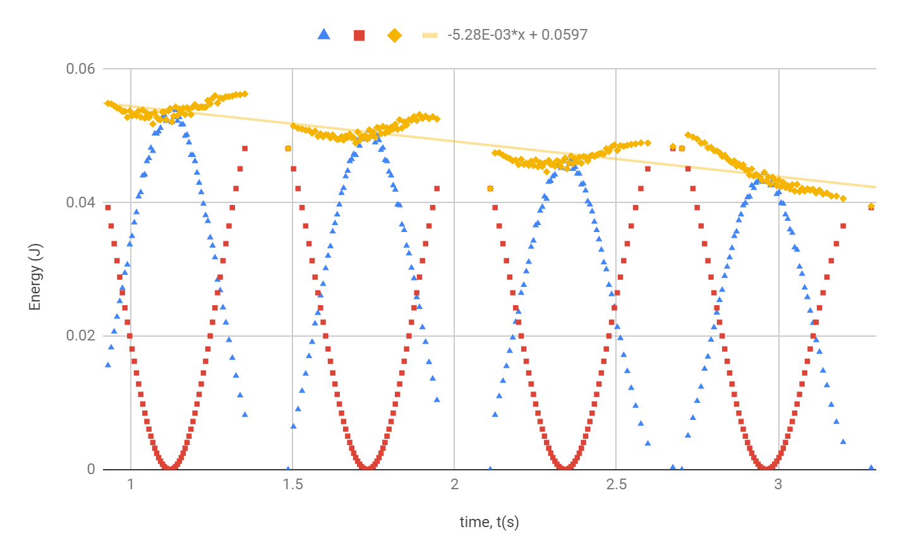

**Figure 6. Multiple Oscillations of Kinetic Energy, Potential Energy, Total Versus Time** This graph displays the kinetic energy, potential energy and total energy as a function of time. The trendline of the total energy displays a decrease over time, which represents the loss of energy to friction. For the glider to decrease its amplitude by a factor of *e*, it would take about 514.8 seconds.

**Conservation of Mechanical Energy**

Amanda Wei2

The conservation of mechanical energy is a well-accepted principle that is understood to in all processes. To verify this principle, our experimental setup consisted of a omb propped upon a glider that was attached to springs on either side and allowed to move laterally along an air track. After the timer started and the glider released, a photogate recorded the time whenever a tooth of the comb passed by. Taking the time data points recorded by the photogate along with measurements of the length of the comb and each tooth-gap pair, data for velocity, kinetic energy, potential energy and total energy were derived. The various energies were plotted against displacement. Linear regression was performed on the set of data points for total energy and a line of best fit was plotted, whose slope which indicated a slight decrease in total energy as displacement grew. This is not unexpected and does not violate the premise of total conservation of energy because the loss in energy can be attributed to friction between the air track and the glider.

Word count: 176

[1] Physics 4AL: Mechanics Lab Manual. UCLA Department of Physics & Astronomy. 54:54. 2018.

[2] College of Letters and Science, University of California, Los Angeles